**Study of gcc**

**Que1) Running C Language program using gcc command**

#include <iostream>

using namespace std;

int main()

{

int a, b, c;

cout << "Enter two integers to add\n";

cin >> a >> b;

c = a + b;

cout <<"Sum of the numbers: " << c << endl;

return 0;

}

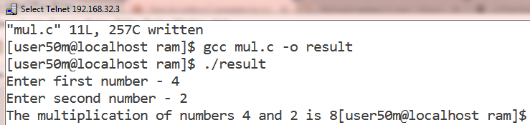

**Que 2) Running c++ Language program using g++ command.**

#include<stdio.h>

void main()

{

int one, two, multiply;

printf("Enter first number - ");

scanf("%d",&one);

printf("Enter second number - ");

scanf("%d",&two);

multiply = one * two;

printf("The multiplication of numbers %d and %d is %d",one,two,multiply);

}

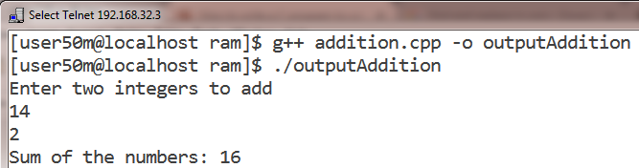

**awk -** pattern scanning and text processing language

AWK name comes from the last initials of the three authors Aho, Kernighan and  Weinberger. AWK program is a sequence of pattern {action} pairs  and  function  definitions.  Short programs are entered on the command line usually enclosed in ' ' to avoid shell interpretation.  Longer programs can be read  in  from  a  file with the -f option.  Data  input is read from the list of files on the command line or from standard input when the list is empty.  The input is broken  into records  as  determined by the record separator variable, RS.  Initially, RS = "\n" and records are synonymous with lines.  Each record is  compared  against each pattern and if it matches, the program text for {action} is executed.

**Syntax:**

awk program [file]

where program is composed of one or more pattern {action}

**Options:**

-F value     sets the field separator, FS, to value.

-f file          Program  text  is  read  from  file instead of from the command line.  Multiple -f options are allowed.

-v var=value   assigns value to program variable var.

**Examples:**

$cat file2

this is india

this is maha

This is mumbai

this is bandra

this is VESIT college

this is first year mca

$awk '/this/' file2

this is india

this is maha

this is bandra

this is VESIT college

this is first year mca

$awk '/college/ {print $3}' file2

VESIT

$awk '/this/ {print "---------" $3}' file2

---------india

---------maha

---------bandra

---------VESIT

---------first

$cat > file3

Metal          Weight Country Description

Gold           1            India   Good

Silver         2            Peru    Average

Steel           3            Brazil  Poor

Bronze  4     Japan   Best

$

$awk '/Gold/ {print $2 " Rank " $3}' file3

1 Rank India